SanDisk Desk Drive - 4TB

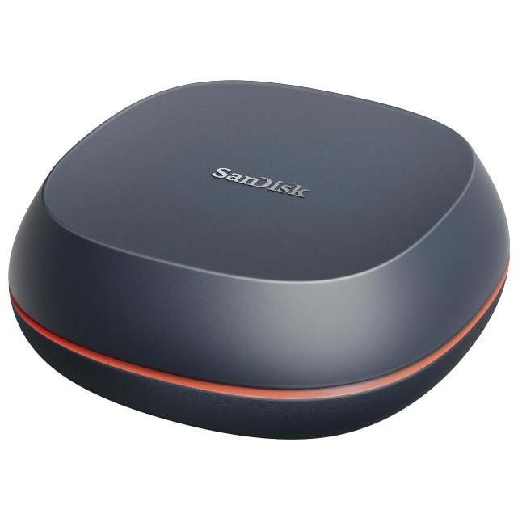

**Key Specifications**

* **Capacity**: 4TB
* **Interface**: USB 3.2 Gen 1 (Type-A or Type-C, depending on model)
* **Sequential Read/Write Speed**: Up to 150 MB/s
* **Form Factor**: Desktop external drive

**Design and Build**

* **Durable Enclosure**:  
  Built to withstand everyday use with a sleek, modern design that complements any workspace.
* **Desktop-Friendly**:  
  Compact form factor with a non-slip base for stable placement.

**Energy Efficiency**

* **Eco-Friendly Mode**:  
  Power-saving features help reduce energy consumption during idle times.

**Warranty**

* Backed by a **3-year limited warranty**, ensuring long-term support and reliability.